Background Information

Strain Number | T005158
Strain Name | B6/JNju-Fbxo3^{em1Cflox}/Gpt
Used name | Fba; AI046358; 1200002G09Rik; 1700026K02Rik
Common name | Fbxo3
Complete time | 2019/2/27
Strain Type | Conditional Knock out Cas9
origin | Gempharmatech
Background | C57BL/6J
Algebra | F0+F1
appearance | Black
Related geneS | Fbxo3
genotype | Fl/wt
Provided genotype | Heterozygote
Targeting Strategy | 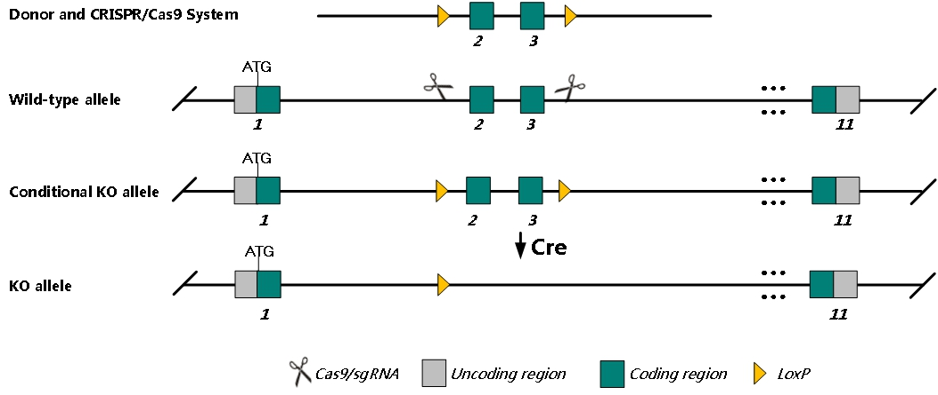
sgRNA | GGTGAGTCTGTAGTCGAAAT AGG AAGATGGGTTCTAATGAGTC AGG
Breeding method（♂x♀）
status | frozen
Genotyping | PCR+Sequence
Special feeding conditions | None
feed | SPF
maternal instinct | general
Strain description | /
Research areas | /
Reference

