Background Information

Strain Number | T005152
Strain Name | B6/JNju-Fbxw17^{em1Cflox}/Gpt
Used name | C85886; 1110064L07Rik
Common name | Fbxw17
Complete time | 2019/3/4
Strain Type | Conditional Knock out Cas9
origin | Gempharmatech
Background | C57BL/6J
Algebra | F0+F1
appearance | Black
Related geneS | Fbxw17
genotype | Fl/wt
Provided genotype | Heterozygote
Targeting Strategy | 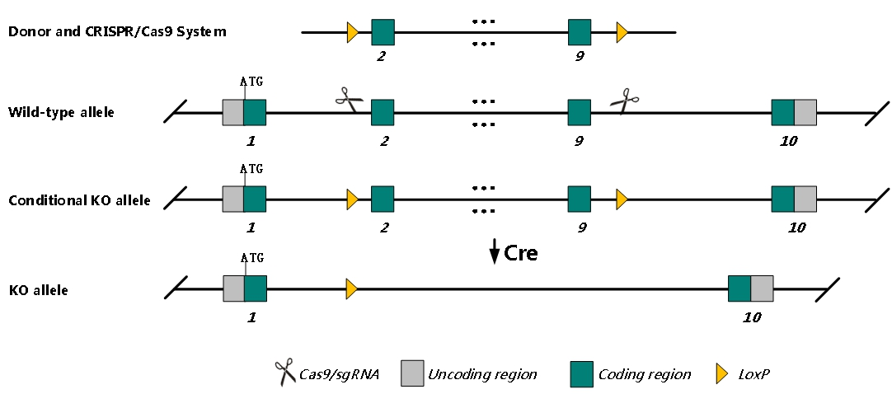
sgRNA | TGACAAACTGTTACAATGTG AGG AAGTGTGGGTAGTACCAGCA TGG
Breeding method（♂x♀）
status | frozen
Genotyping | PCR+Sequence
Special feeding conditions | None
feed | SPF
maternal instinct | general
Strain description | /
Research areas | /
Reference

